Questionnaires – interviewee

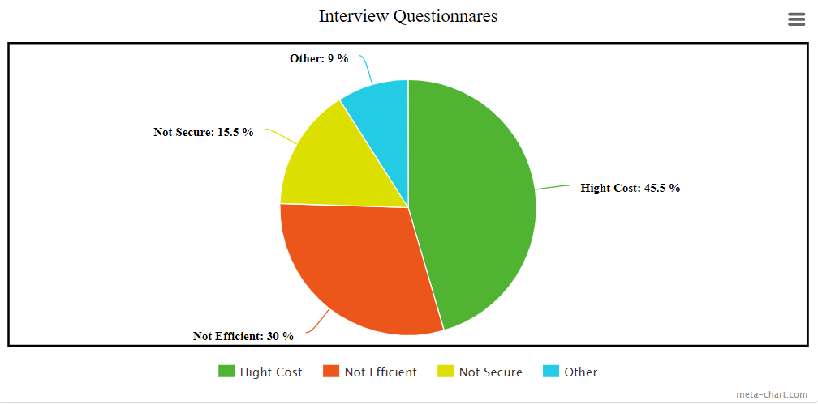

Questionnaires are given out to a total of 50 interviewee of National Library of Malaysia to collect their response towards the current Library Management System. Based on the pie chart above, it shows that most of the interviewee (45.5%) agreed that the current system which costs are high. For example, the old library management system there are many manual procedures. So, the library needs to hire more people to complete the work.

Besides that, 30% of interviewee are unsatisfied with the current system which are not efficient. This is because the current system has poor performance, inflexible and difficult to use.

Moreover, 15.5% of the interviewee agreed that the current system is not secure. This because this system has no authorization access required. It is dangerous for the company because the unauthorized person such as hacker could access sensitive information in this system.